Dwight Thomas

Structures of Programming

Assignment 3(Syntax Analysis).

URL to GitHub:

<https://github.com/dwightthomas/StructureOfProgramming>

5 Main commits

1. Date: 03/22/17 Time: 6:30pm

Description: This was me setting up the code from the text book and making sure to realign my indentations and comments so all the structure was there as well as testing that code to ensure it works as it is supposed to.

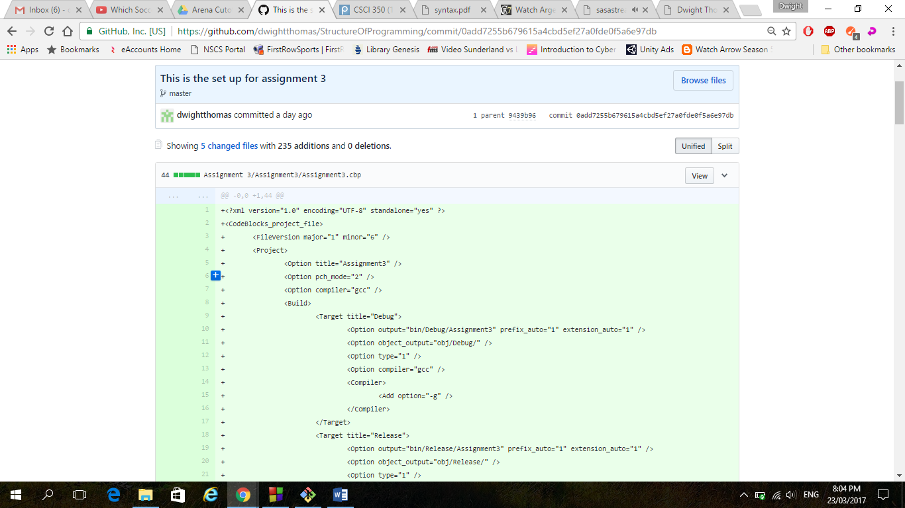

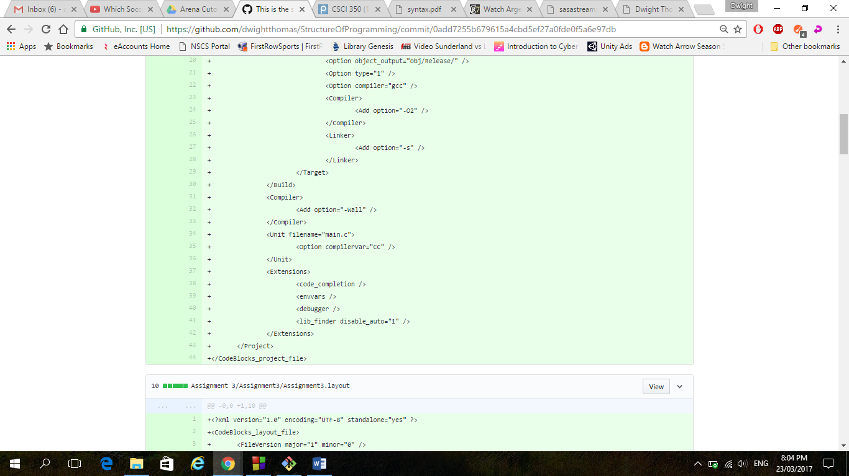

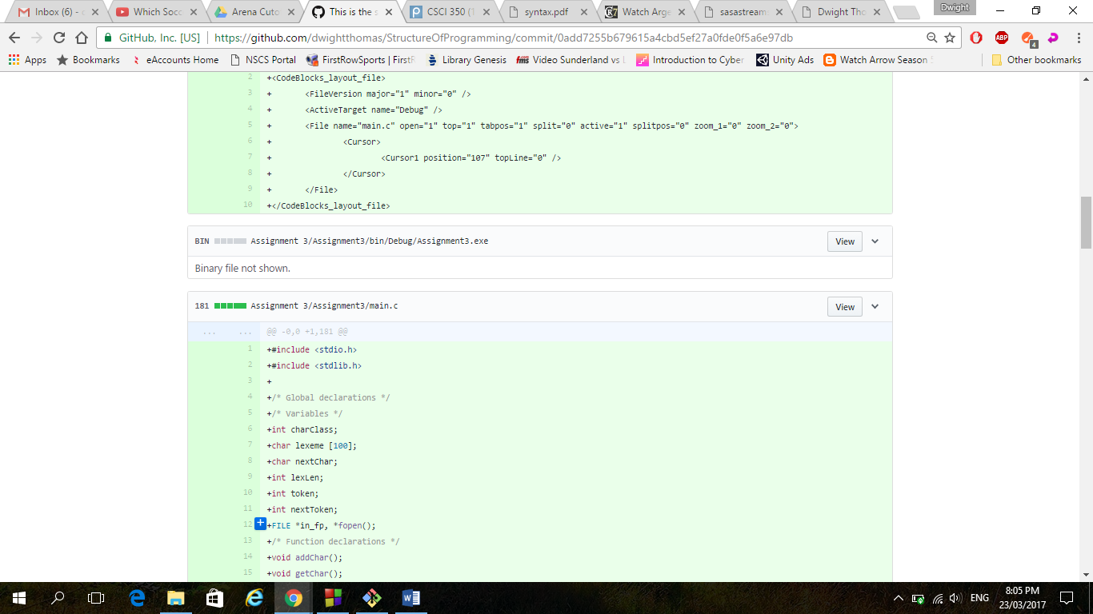

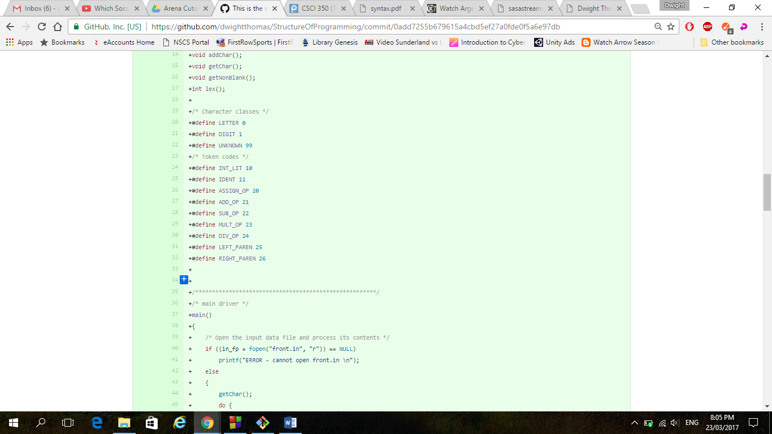

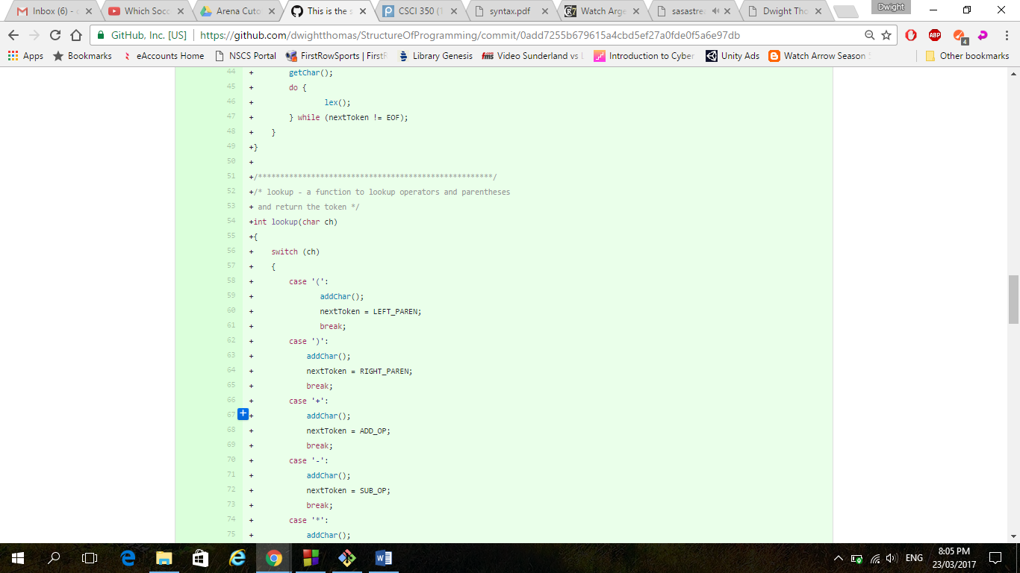

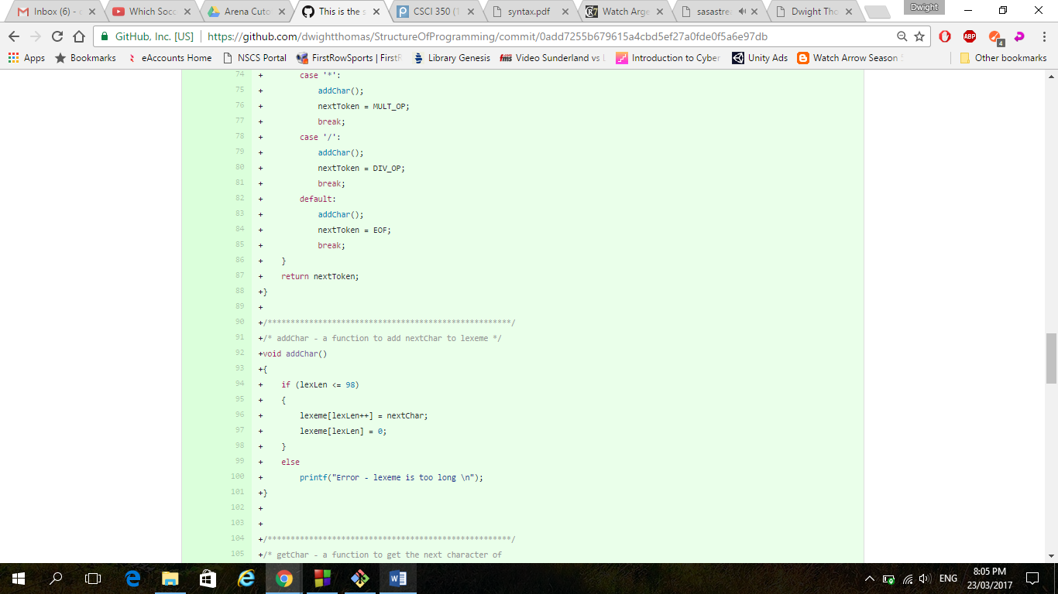

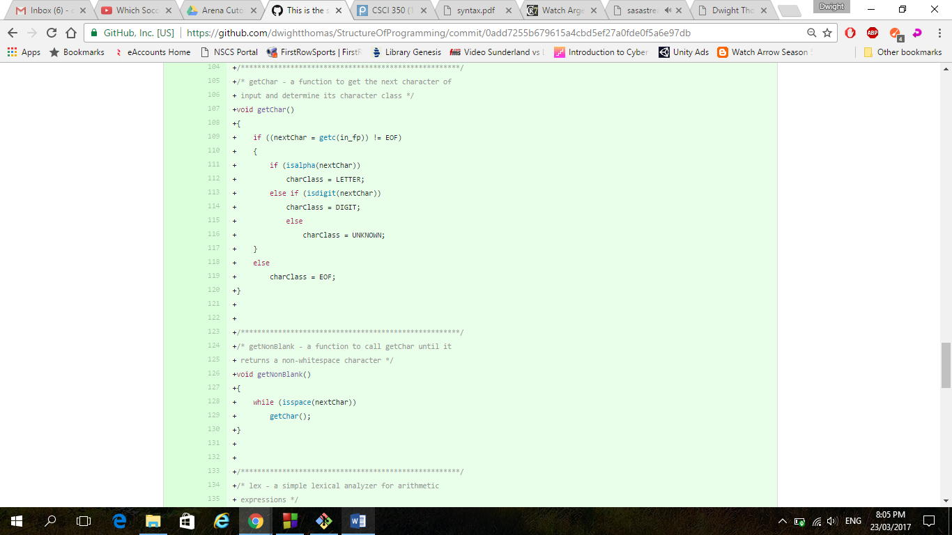

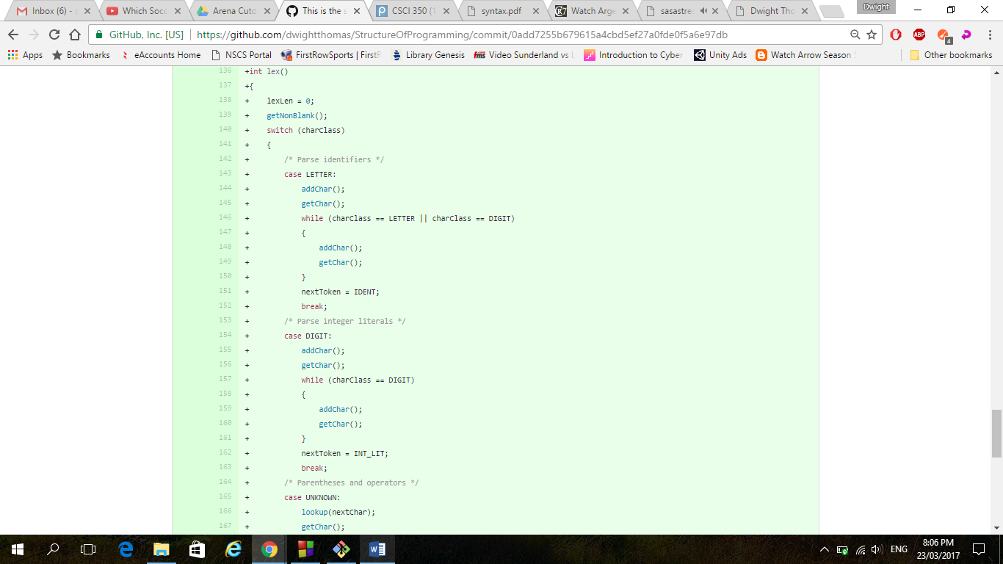

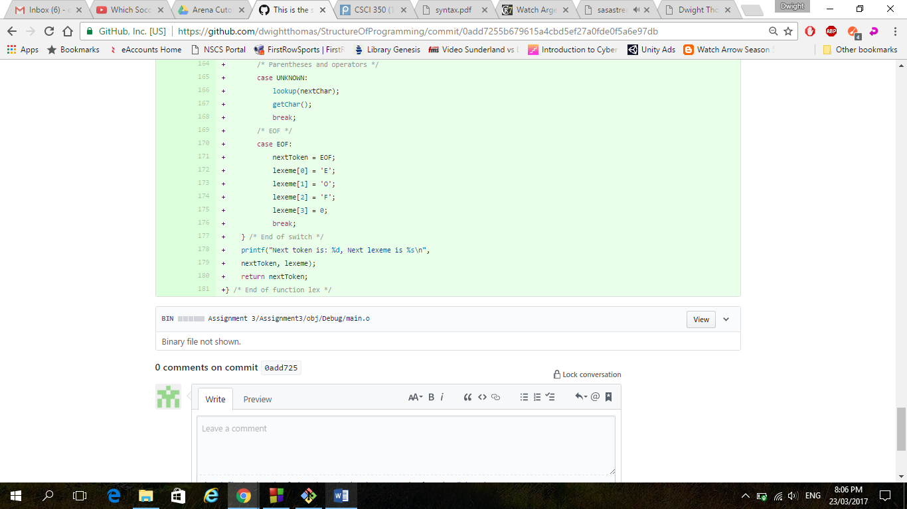

1. Date: 03/22/17 Time: 7:30 pm

Description: This was after getting all the code from the two different segments in the text and combing them and making sure they were working properly as well as making some minor changes.

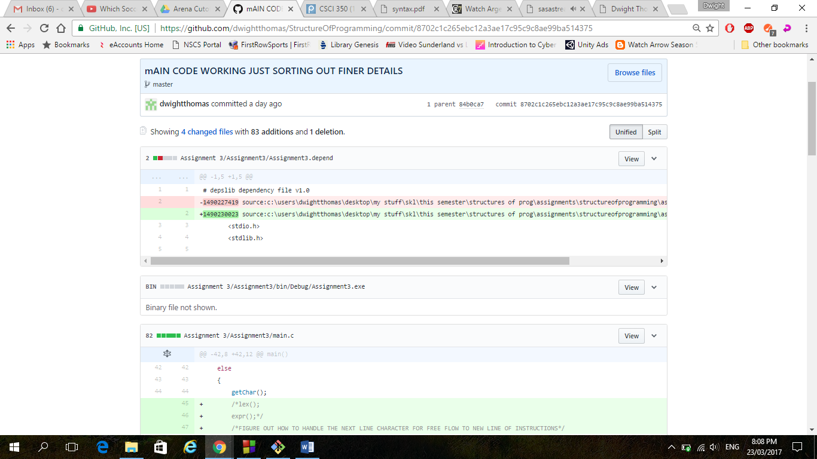

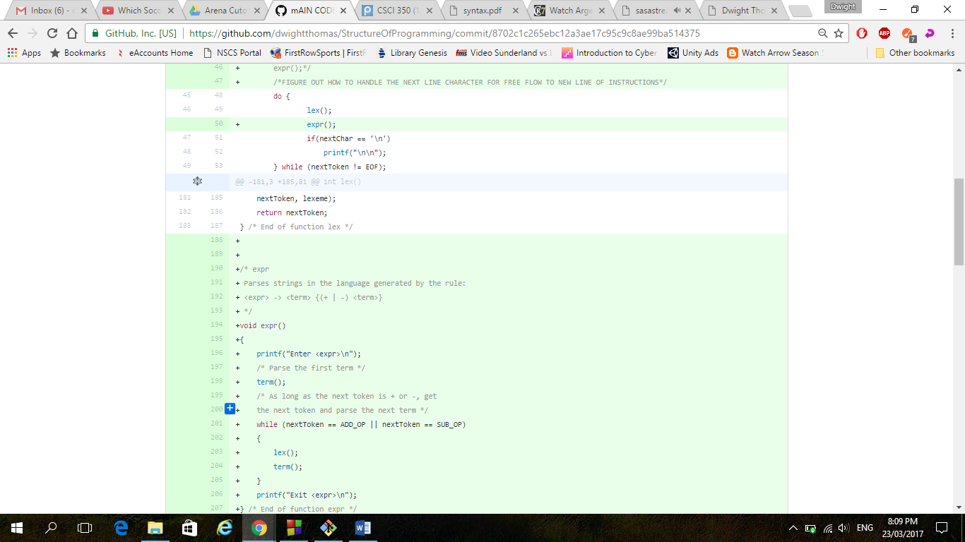

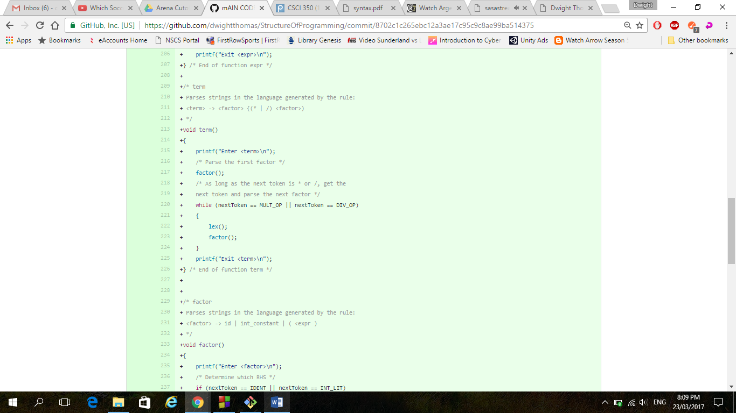

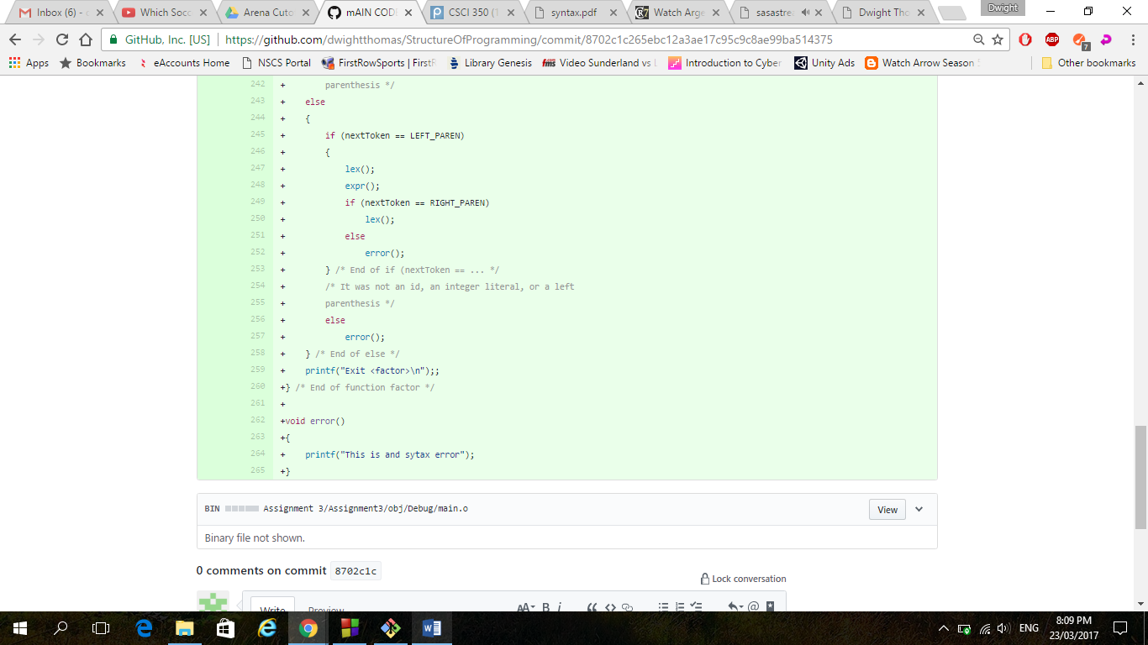

1. Date: 03/23/17 Time: 12:00pm

Description: This is where I added in code to deal with multiple lines of instructions. I added other stuff to deal with next line character to help me know that I am going to another line and thus new input.

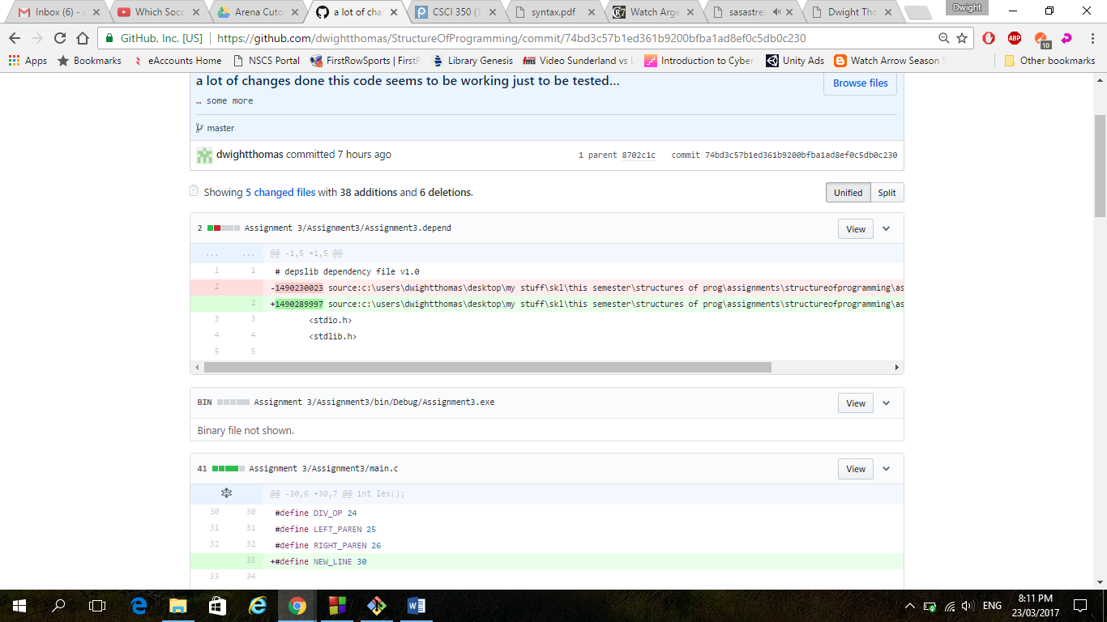

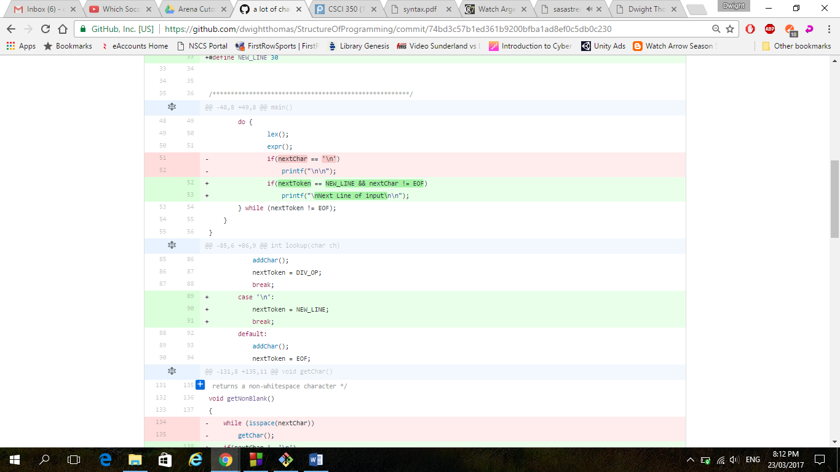

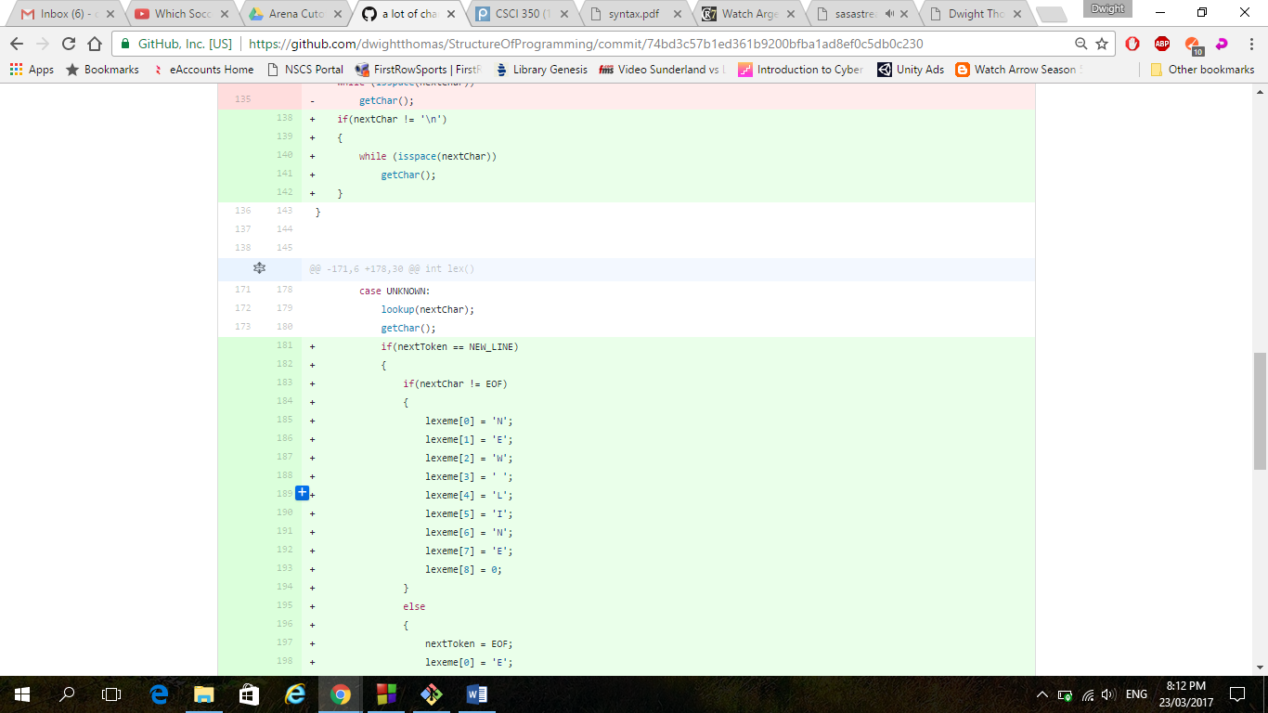

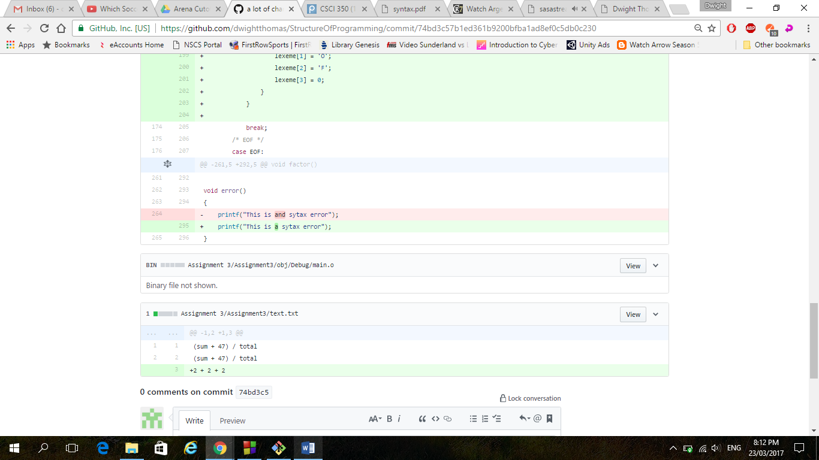

1. Date: 03/23/17 Time: 1:12 pm

Description: This was where the code was finalized and tested as to what I understood to needed to be implemented. I also did a small working version of my error functions to deal with syntax errors.

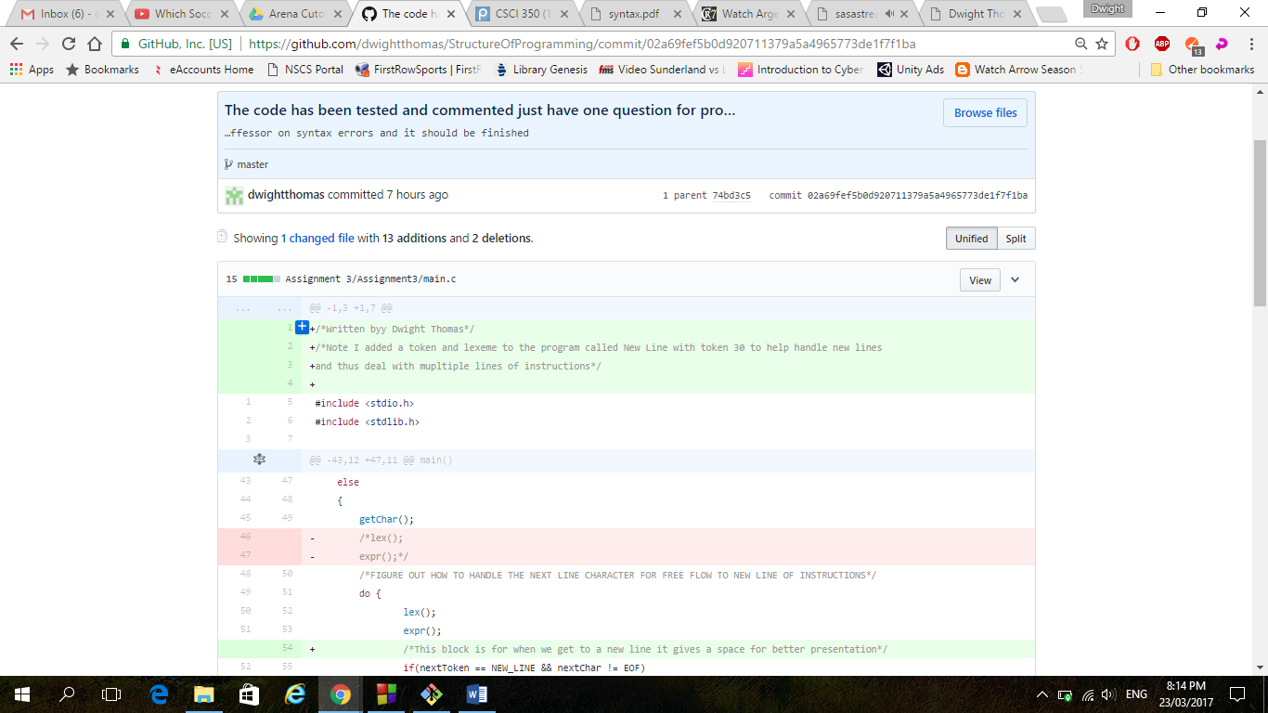

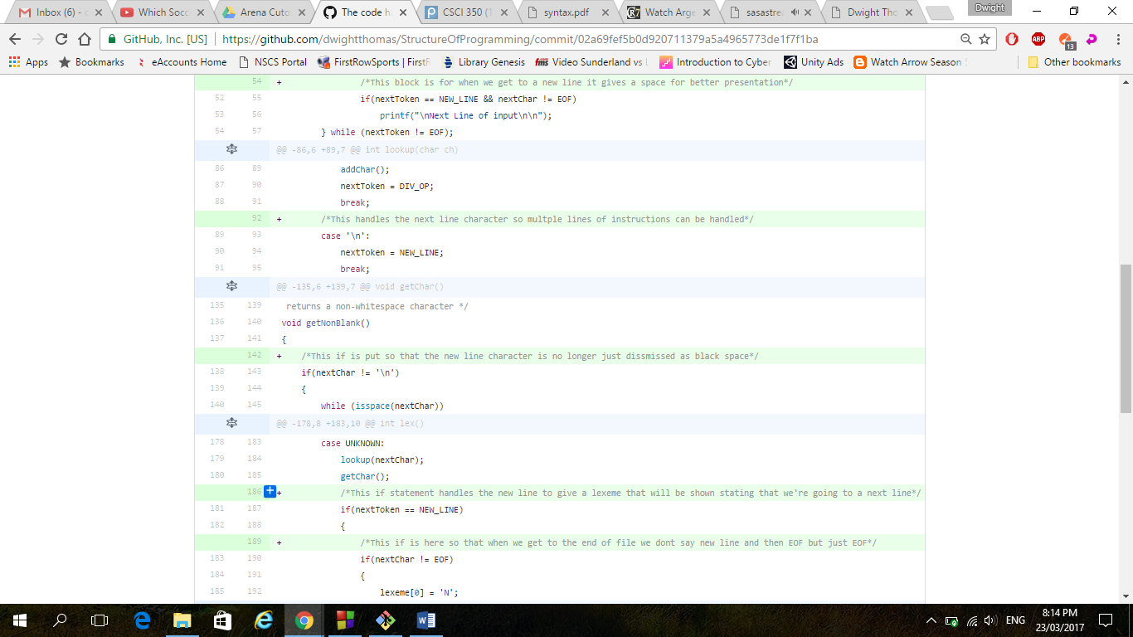

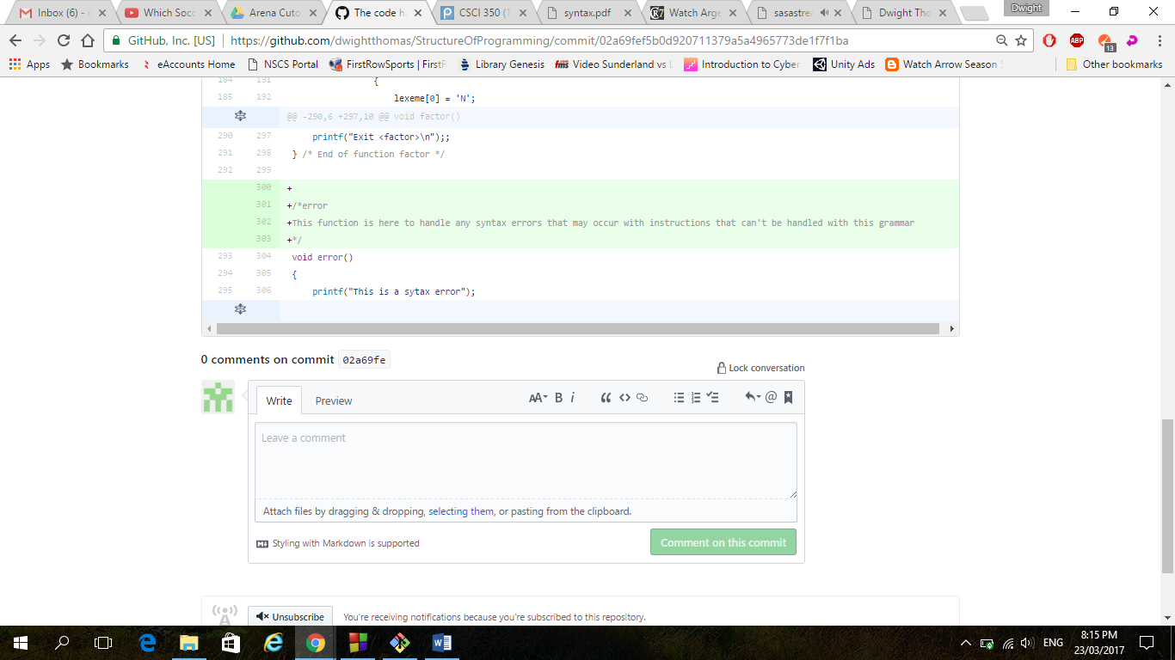

1. Date: 03/23/17 Time: 7:30 pm

Description: This was a more thorough version of the error function that better handles errors as to how was required by professor also changed and improved the presentation of the going from one line to another.

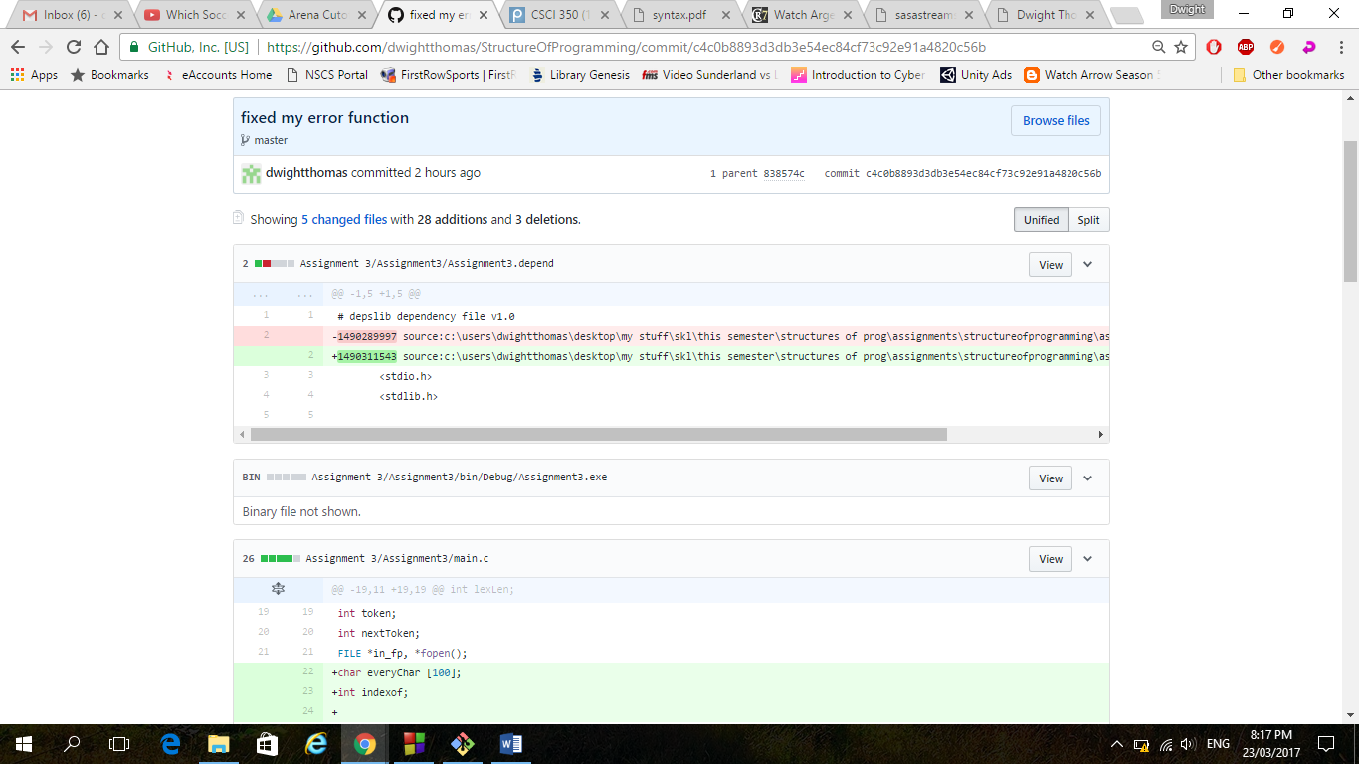

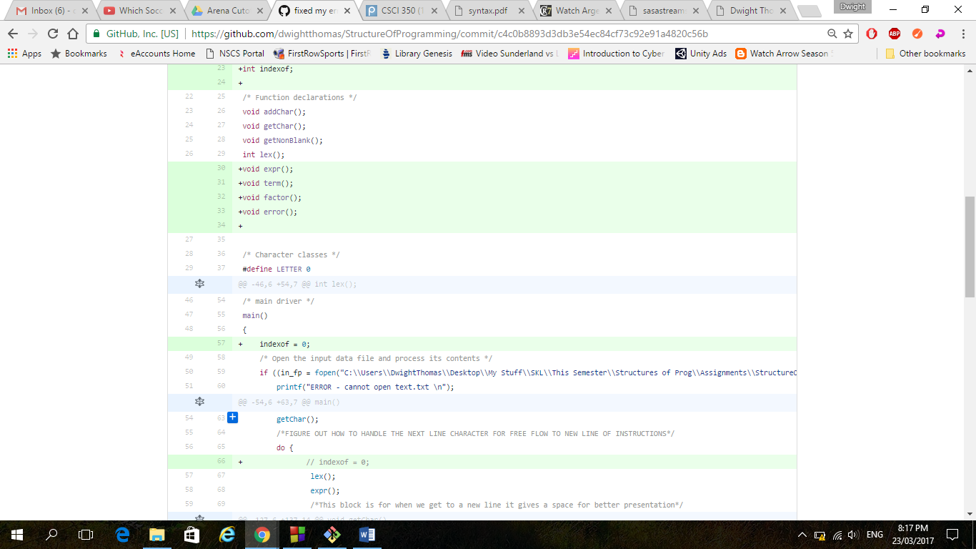

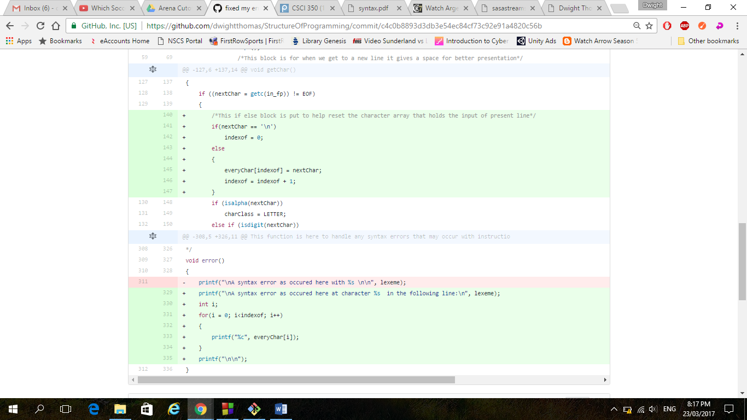

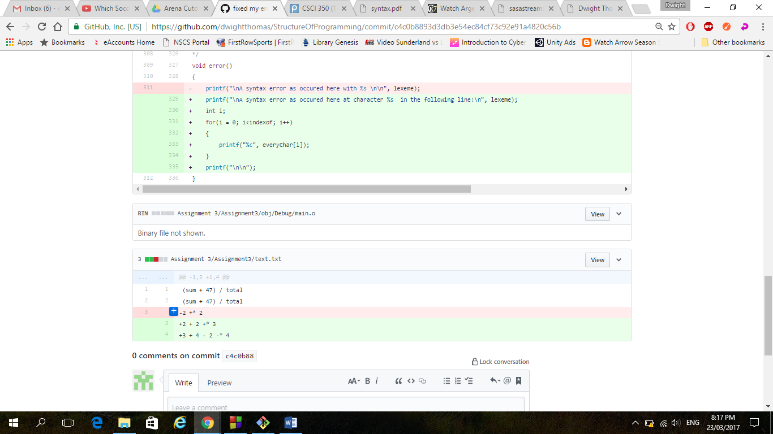

Special instructions: I have placed a text file in the folder with my main code, I coded it using the code block IDE so to run the program with the file having a proper file name just change the file destination of the folder. Once that is changed the program will run properly. So the only thing that needs to be done is to change the file destination in the first if block of the main specifically line 60.

I also put a word version so I didn’t lose any formatting.